6.18: As the example explains, the boats have the same kinetic energy K at the finish line, so 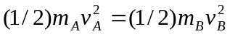, or, with 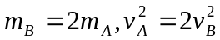. a) Solving for the ratio of the speeds, 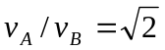. b) The boats are said to start from rest, so the elapsed time is the distance divided by the average speed. The ratio of the average speeds is the same as the ratio of the final speeds, so the ratio of the elapsed times is 

